1st Grade Connection
March 23-27, 2026
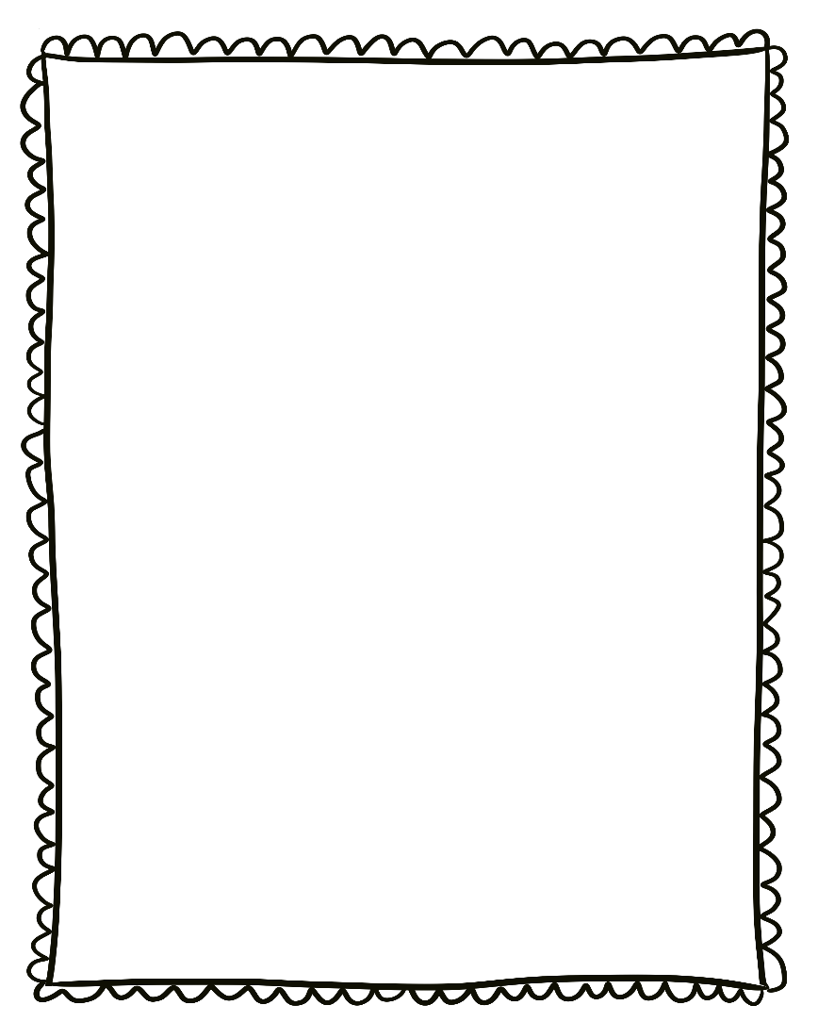
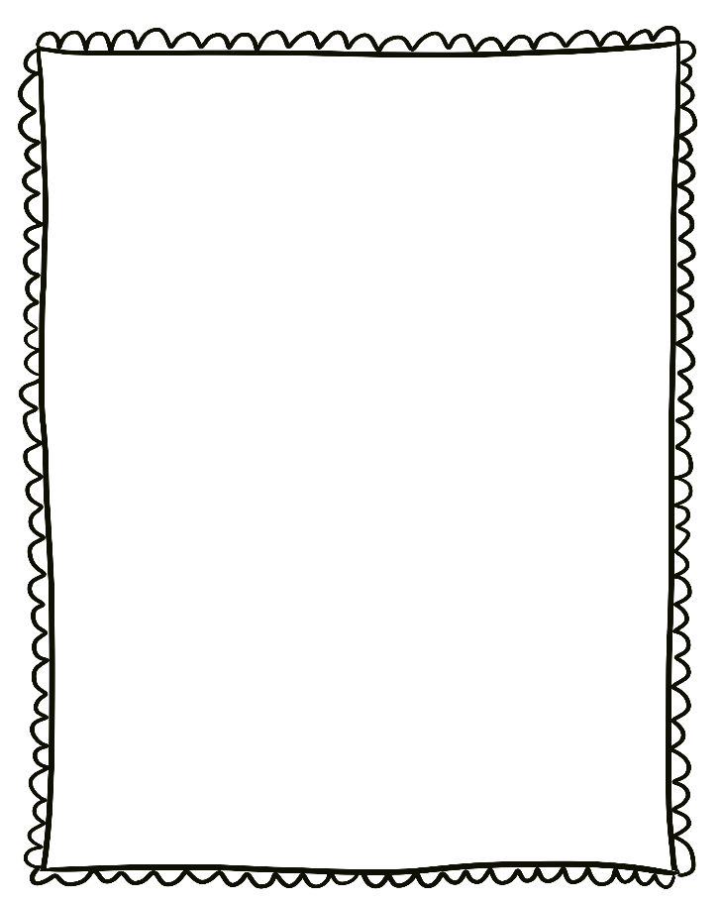
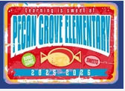
- Wednesday, March 25th: College Wear Wednesday

Reminders:

- Please send a nutritious snack that is easy to eat to school with your student. All snacks must be peanut free. Examples of this include Cheez-Its, Pretzels, or baby.
carrots.

- Wear tennis shoes on PE days!

- Reading: Mo Willems Author Study

- Phonics: Long o vowel teams -oa, -oe

- Writing: Author’s Craft

- Conventions: Review

- Math: Problem Solving

- Social Studies: Needs and wants

- Science: Living and Nonliving

Upcoming Events/Grades
What we are learning:

